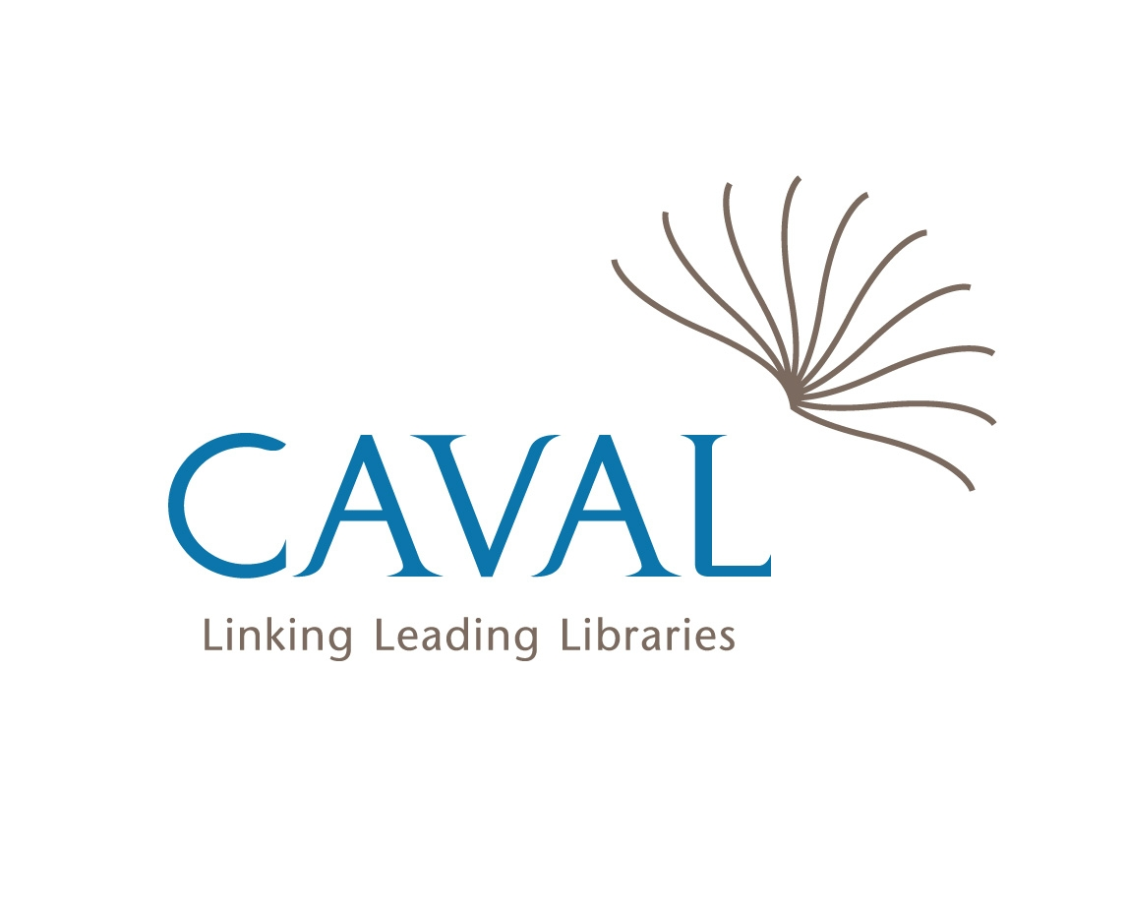
Caval Reciprocal Borrowing Telephone Authorisation
Name of institution | New  enrolment | Renewal | Time of day |  |  | Authorised |  | Phone contact not made | Comments
 |  |  | 8-6 | After 6pm | Weekend | Yes | No

